

GUI Programming CA : Barber shop App.

Student: Alisson Alves De Moura.  
Student Number: 2019142 Lecturer: Me. Amilcar Aponte

# Objective:

The objective of this project is to create an application that facilitates the appointment scheduling for a hairdressing company and its customers. So that it is intuitive and easy to handle by professionals and customers.

# Presentation proposal

The purpose of this document is to explain the project planning, presenting a wireframe of the necessary screens and their characteristics.  
Informing the reader about the features adopted how they should behave for the user, and why they were chosen.

## 1 – Login Screen

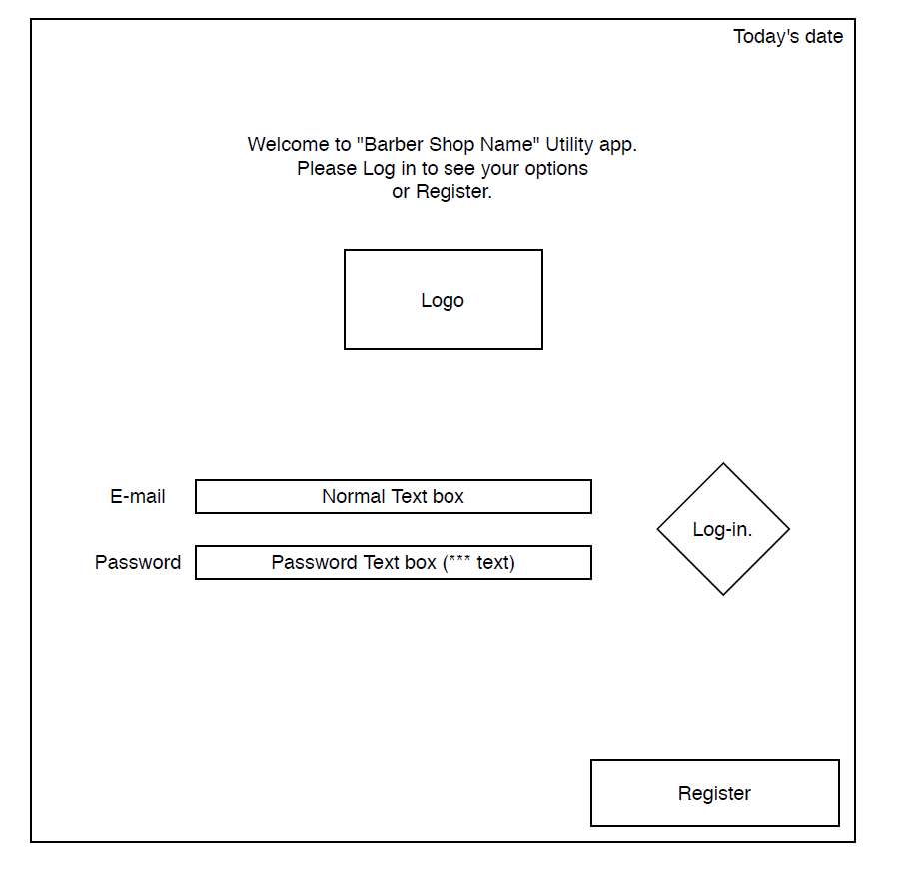Login screen objective is used to give the user access to his/her profile, where they can access features designated for customers or barbers, accordingly to their objectives using the app.  
The login screen also gives the user the possibility to be directed to another screen where they can register to the database, in case the customer doesn’t have it.

The frame show today’s date on the top right corner, as it’s an appointment app, knowing the date is vital importance for every user.  
A message is shown to inform the user important information about how the user can interact with the features shown.  
A logo frame shows the company Logotype, informing the user what company the app will be scheduling appointments for.  
Two text boxes with labels beside it will collect e-mail and password information from the user for login into the database, one text box will be set for not to show the data typed, as it is confidential. The log-in button is beside it to make it easy to find the submission button to finish the authentication.  
If the information in Log-in is located into the database, it will close the frame and open another frame to show the user information for its profile. If no profile is found in the database a simple error message informing the user will pop up informing the lo-in wasn’t possible and why.  
A register button is placed no aligned to the other centralized features, in order to draw attention of “first time” users, who might want to register. If clicked, the frame will be closed and the registration frame will be shown on the window.

## 2 – Registration Screen

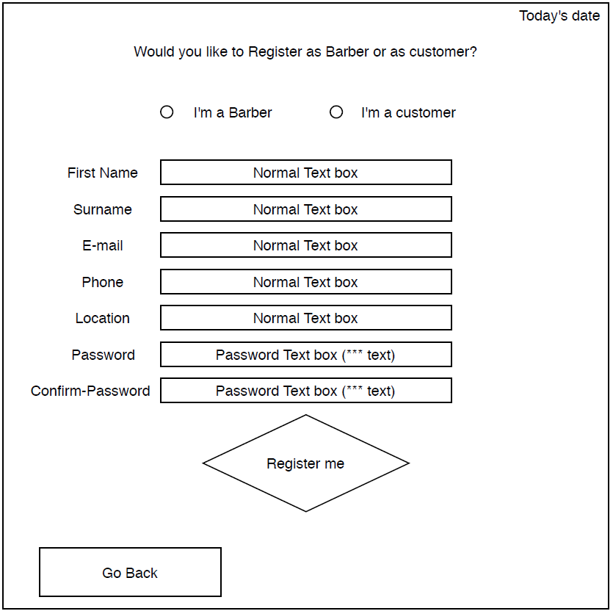Registration frame objective is to make a fast collection of the user’s information for a new entry into the database. As in general there’ll be two different types of users, the registration will give the possibility to register a user as barber or as an customer.

The frame show today’s date on the top right corner, as it’s an appointment app, knowing the date is vital importance for every user.  
A message asking the user for what type of user they are will be shown and underneath it two “tick-boxes” will give the user the option of registering as Barber or customer. The standard option will be Customer to make registration easier in case the user doesn’t pay attention to the message.  
If barber is chosen the “location” textbox will be unhidden, if not as just barbers must have location, this will be hidden for customer users.  
All information collected will have normal text boxes but password boxes, as it will be confidential information. The “Register-me” button will be placed just beneath all text boxes, as the user interaction flow drags eventually the user attention to it. This will check information in the boxes, close the frame and open a “registration message” frame.

The “go back” button will give the user option to go back to the Log-in frame, closing the registration screen and opening the log-in frame again. The objective is in case a user clicked onto “register” by mistake before.

## 3 – Registration message

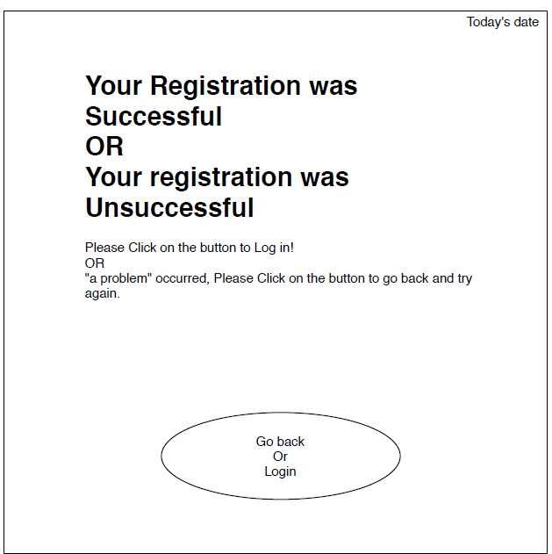Registration message frame objective is to inform the user, after clicking onto “register-me” button if all data set into the text boxes were successfully submitted, and in case it wasn’t it will inform the user an error occurred and possibly will inform the user how to submit it avoiding the mistake.

The frame show today’s date on the top right corner, as it’s an appointment app, knowing the date is vital importance for every user.  
A message informing in big letters whether the data was submitted successfully or not and instructions on how to proceed in either case.

A button will be shown in either case, but in case it was successful it will direct the user to the “Log-in frame” if the registration was not submitted, the button will direct the user back to the registration frame to try again.

The idea of keeping this window with easy information and just a button is not to make the users upset with overwhelming amount of information and buttons, considering the user was confused before to make a mistake, we can make sure the failure on the registration is noted a second time by sending the user back to registration frame, instead to have the risk of another mistake where the user tries to log-in with information that isn’t in the database.  
If the user just wants to leave, the option will be shown on the next frame regardless.

## 4 – Customer Main Page.

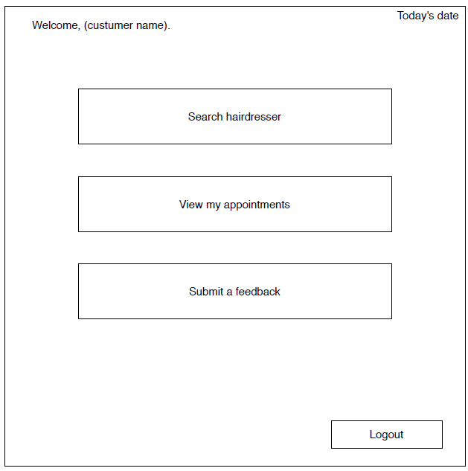The customer frame objective is to show the user they have options to interact with the platform and explore it, a button for each feature will be shown in a open distribution where the customer can choose from and navigate through the platform.

The frame show today’s date on the top right corner, as it’s an appointment app, knowing the date is vital importance for every user.

A short welcome message with the customer’s name will be shown on the top left corner, this feature is to make the page personalized for the user and also to avoid mistakes in case a login was made into the wrong profile, as it can happen in several cases as for instance when parents want to make appointments for their children.

Each option for the customer will be shown as buttons to make navigation very friendly. Every interaction with the services the app offers will be shown on buttons aligned on the same grid, the logout button will be shown in a different alignment to be easily found by customers in case it’s needed. Turning the navigation even more friendly, and avoiding “miss clicks”.

## 5 – Search barber

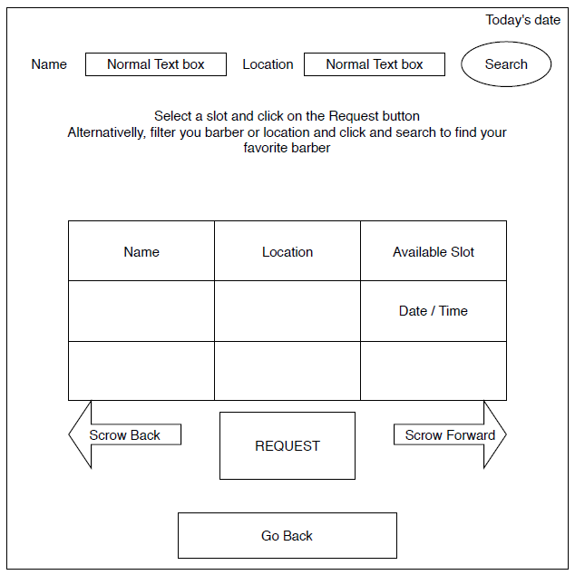Search barber frame objective is to make it easy to find an appointment, which will give the user option to submit request for “time-slots” barbers offer on their agendas.

The frame show today’s date on the top right corner, as it’s an appointment app, knowing the date is vital importance for every user.

Boxes to filter information will be shown, the label beside each one inform the customer what will be filtered on their research, the “search” button beside it follows the eye’s move as the customer is reading from left to right.

A static message is shown informing the user how to book an appointment, it’s centralized after the filter as per be more centralized and easier to be read and just before the table it’s explaining how to interact to.

A table labelled with all necessary information for a appointment will be shown, if no search is submitted, it should show all available slots to be booked sorting by closest to today’s date, if a search was made, it will filter just information matching the string typed in the boxes.

Buttons after the table are labelled informing how to interact with it. On the right site it has a button (possibly in a right side arrow shape) that will search the next slots going towards the future.  
The opposite is valid for the other arrow. The table won’t show past slots neither a inexistent slot.  
That easy navigation helps the user to easily scroll the available appointments in a user-friendly way.

The request button is centralized to be easily found, this button closes the actual frame, and try to submit the registration up to the database and opens the “request message “ frame.

The “go back” button is also centralized but as isn’t positioned close to the table, it cannot be confused as an “interaction” button, therefore a miss click is less probable, this button will send the customer back to the Customer main page, in case the customer change their mind or in case of this option was selected by mistake.

## 6 – Request message

Request message frame objective is to inform the user, after clicking onto “request” button if the slot was successfully submitted or not. In case it wasn’t it will inform the user an error occurred and possibly will inform the user how to proceed.

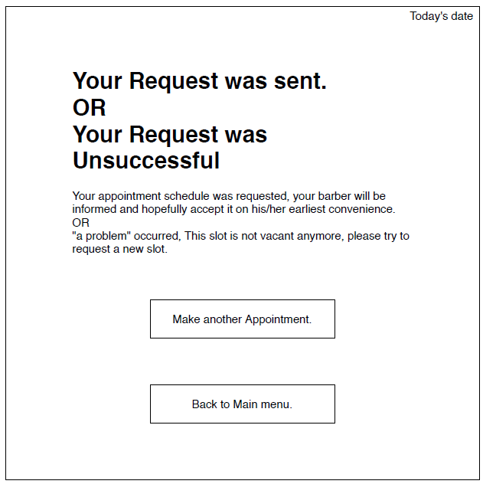The frame show today’s date on the top right corner, as it’s an appointment app, knowing the date is vital importance for every user.

A message informing the customer the slot was sent or not to the barber’s agenda will be shown, it will informing the barber will be informed and should answer to the request or that an error occurred and how to proceed in case of failure. It’s important to inform the user appointment was sent but isn’t yet confirmed to avoid misunderstandings, an in case of failure the option of trying it again.

A button to “make another appointment” will be shown in each scenario, as customers can have multiple appointments scheduled or in case the customer wants to try again.

A button to go “Back to Main menu” will be shown on each scenario, as customers might not want to request other appointments or in case the customer changed their mind about making appointments for now. Positioned as the last option in the page makes the action intuitively less interactive with the text.

## 7 – Customer’s Calendar

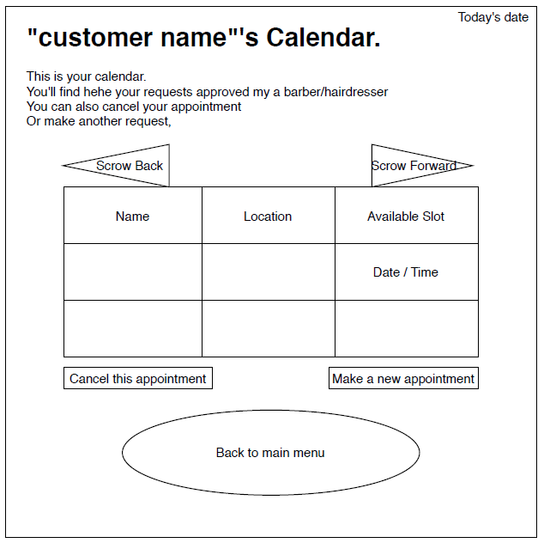Customer’s calendar frame will inform every request that was accepted by a barber/hairdresser.  
Here the customer can manage their appointments and have an overview of all accepted agendas.

The frame show today’s date on the top right corner, as it’s an appointment app, knowing the date is vital importance for every user.

A title text informing in big case what the frame is about, personalizing the user name on it and lower case information for user interaction.

Buttons for table navigation that work the same way the “search barber” arrows is set on each side labelled with their functions.  
An easy navigation in a different design in order not to confuse the user on what page is he/she in.

A table showing all accepted requests, with all important information and sorted by date from closest to today’s date towards the future. It’s important just to show what was accepted and not both requested and accepted to avoid confusion, of no appointment was confirmed the user will have option to ask for feedback later on.

A button to cancel appointment can be used, just by selecting an appointment and clicking on it will instantly request to delete it from the database, this feature is important for customers that have plans changed or for any other reason have to cancel the booking. The position close to the table makes intuitive it’s interaction to the table

A button to make a new appointment is placed close to the table aligned as well to it, like the other buttons surrounding are for table’s interaction, this one will send the customer to the Search barber’s frame, where they can easily make an appointment, this button is duplicated as the path will be easier and even more intuitive than the alternative of going back to main menu to make an appointment.

There’ll be the option to go back to main menu in case the customer finished everything they want to do in this frame and want to go back to the main menu. It’s not aligned to the table to intuitively make the user understand it’s the option to go back.

## 8 – Send Feedback

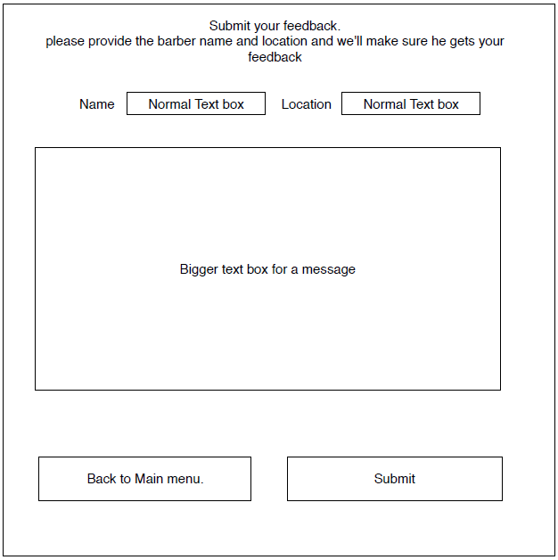Submit feedback frame have the objective to make communication between with customers and service providers in a fast way.

The objective is to make is easy to type and send, as feedback tends to be something people doesn’t have much patience for.  
A fast message on the top will be shown informing how to proceed, to make sure the user understands how to send the message and how to make the message go to the right service provider.

Boxes for name and location will be shown to reach the service provider’s database information and be processed accordingly.

A bigger textbox will be available for the customer to write everything the feedback need to have, and it has to be big in order to make the customer see a big chunk of text in case they want to revise it for any reason.

A Button to go back to main menu positioned on left corner work as other message apps that use by convention left cornered buttons as “go back” buttons. Will direct the customer back to main menu.

A submit button positioned on the right corner works as other message apps that by convention right sided buttons as “Submit” buttons. Will direct the customer to the “Feedback message” frame.

## 9 – Feedback Message

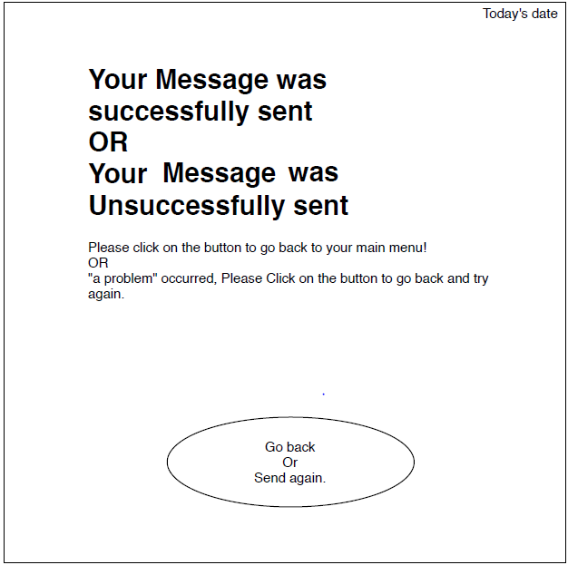Feedback message frame objective is to inform the user whether the form submission from feedback page was successfully sent or not, and possibly how to fix an eventual problem.

The frame show today’s date on the top right corner, as it’s an appointment app, knowing the date is vital importance for every user.

A message informing whether the feedback message was or not submitted in big letters and small letters message with information that complements the comment. To make the user interaction easy and inform how to proceed, and positioned occupying big part of the frame to make it easy to read and understand.

Just one button is shown to make user’s interaction, The button is centralized to make it easy to see and it’s the only one to avoid mistakes to be made in case of error or misunderstanding of the message, just like the registration screen.  
If successful the button directs the user back to main menu. If unsuccessful the button directs the Customer to the feedback screen again.

## 10 – Service provider Screen

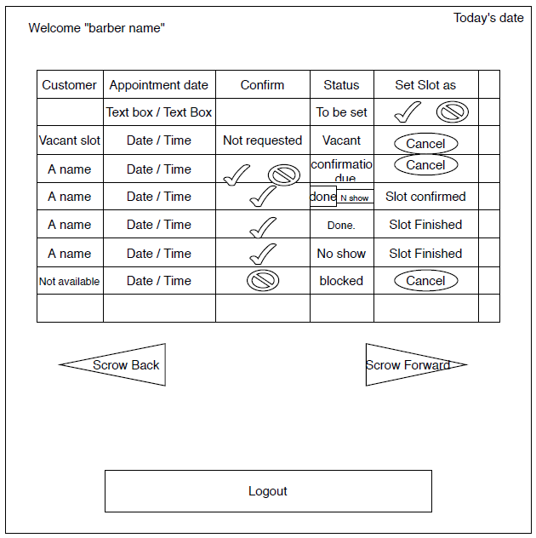Service provider’s screen’s objective is to make interaction fast and objective, it shows all information the barber needs to know and interact with on the same frame.

The frame show today’s date on the top right corner, as it’s an appointment app, knowing the date is vital importance for every user.

A welcome message is shown to inform the login was done in the right profile and to make it a personal platform to make the employee recognized.  
A interactive table shows the professional agenda, with options on how to interact with it.  
Just the second line location will be always a line where the professional sets new dates, other entries will be sorted by date just like customer’s agenda.  
  
**The first line** shows labels to indentify column’s information, making the navigation understandable by the user.

**Second line** is fixed and it’s where the service provider can set free slots on the database. The reason the position isn’t changed is to make possible to easy to set new time slots at anytime.  
The slot can be set as available to customer’s request or it can be blocked by the barber, if the slot was set it goes to the third line’s state, if blocked, it goes to the eight line’s state.

**Third line** is an example of a slot set as available but not requested by a customer. It’s a state that can be changed at anytime to “line four” if requested by a customer, but it can be cancelled by anytime by the service provider, deleting it from the table.

**Fourth line** is an example of a slot requested by a customer, it can be confirmed, denied or cancelled by the barber. If confirmed it goes to the fifth line’s state, If denied it goes to the third line’s state and if cancelled its deleted.

**Fifth Line** is an example of a requested slot that was accepted. It has the status information with two small buttons for the barber to inform the system if it was a “no show” or if the appointment has happened, the buttons will just be functional after today’s date.

**Sixth and seventh line’s** state are variants of the fifth’s line status, if a button is clicked, the slot is set as finished and the information whether it was done or no show it displayed on status and slot is set as finished.

**Eight line’s** state is an example of a slot that was blocked by the barber; it can be cancelled by the barber if the date’s not passed. It’s just an option in case the barber will be working but not providing services for customers.

Then two buttons for navigation underneath the table to see past or future slots and interact with them, positioned in a intuitive way for users to understand how the navigation is working, and with labels to ensure the information is understood.

A button for logout is placed far from the table to ensure the user it’s not interactive with it, with a big label that informs the user it’s for logout.

In just one screen, every feature can be met and make the professional daily work agenda easy to check and interact with.